

**”** **Veni, Vidi, Vici’’**

**TRAINING COURSE: 09 - 16 November 2019**

***Topola, Serbia***

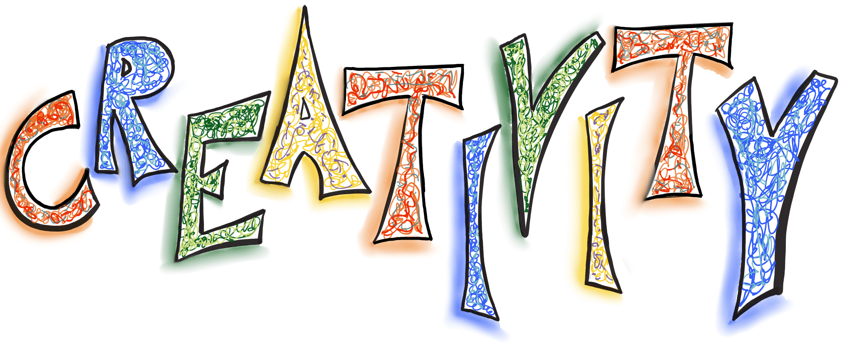



This project has been funded with support from the European Commission. Erasmus+ programme. This content reflects the views only of the author, and the Commission cannot be held responsible for any use which may be made of the information contained therein.

**About the project _______________________________________________________________**

Scientific researches show that creativity is a crucial dimension of learning. In fact, creative thinking is vital, mainly in terms of acquiring knowledge. In a world in constant transformation, youth need to be equipped with several skills to affront any situation and adapt to the world today, develop a satisfactory life and contribute usefully to society.

There are different practices of great effectiveness focused on the creative development. In essence, the young person must be provided with an environment in which he can develop his creative potential, where originality is valued, and where mistakes are understood not as a failure, but as inevitable steps towards learning, always protecting his motivation with a constructive and positive feedback.

For this reason, the organization “ZSD” from Germany and EOM from Serbia is promoting a project to BOOST the CREATIVITY of our youth workers, where there will be a training course as main activity and that will take place in Limassol, Cyprus.

**Objectives_____________________________________________________________________**

The overall objective of our project is to increase the capacities of the youth workers to reveal the creative features of the young who will lead the future.

Our specific objectives are:

- Raising awareness among participants about the importance of creativity in the youth work.

- Teaching participants about different ways of increasing creative thinking's skills.

- Teaching youth workers key activities to develop youth skills, creativity based, and express and produce new ideas.

- Analyzing common factors and attitudes that difficult the development of creativity in young people.

- Disseminating good practices about creativity and its application in all aspects of daily life of youth work.

- Teaching to youth workers behavioral models that trigger creativity.

- Gather and discuss local experiences and new ideas for learning and developing creativity among young people.

- Preparing new project designs to encourage and disseminate creativity among youth inside KA1 Erasmus +.

**Participants____________________________________________________________________**

The participants will be youth workers that are active members of the organizations of the partners involved which:

• youth workers and youth leaders active in non – formal education field;

• Eager to learn more about creativity and creative methods for youth work,

• Interested in developing competences to work as trainers/facilitators,

• Basic experience in leading educational activities with youngsters, at local or international level,

• Open minded,

• Aware of the characteristics of the learning environment (non-formal education),

• Ready to share and explore,

• Preferably working on the youth field and with experience in this learning environment,

• Should have communicative level of English.

• youth workers and youth leaders active in non – formal education field;

• are at least 20 years old;

• are motivated to be fully involved in preparation process (homework’s) and attend at least 98% of the training course.

• are motivated to take part in after training phase (evaluation, self-assessment, etc.).

**THE TC WILL START AT 7:30 PM (DINNER TIME) ON NOVEMBER 09th.**

**09. NOVEMBER IS ARRIVAL DAY; 16. NOVEMBER IS DEPARTURE DAY**

**Finances ______________________________________________________________________**

The youth exchange is implemented by support of the European Commission programme ERASMUS+ and the German National Agency. Travel Expenses (according to Erasmus+ guidelines), accommodation, food and planned activities will be covered by the project budget.

We will reimburse travel costs as listed below on the basis of the *cheapest* possibilities, e.g. second class railway tickets, APEX-flights etc. by bank transfer after the training and the receipt of all ORIGINAL tickets, bills, invoices, receipts, boarding tags/cards etc. Following the guide lines of the Erasmus + programme the travel back must be realised by the participants on direct way within maximum 2 days. In case of longer stays or indirect travelling (holiday travel etc.) there is no chance of reimbursement of travel costs. Missing tickets will not be reimbursed. Please, keep the original tickets in order to get money back.

**REIMBURSEMNT WILL BE AFTER PROJECT ENDED AND WHEN WE RECEIVER REST OF MONEY FROM NATIONAL AGENCY. PROJECT END 05.01.2020.**

**PLEASE INFORM YOUR PARTICIPANTS ABOUT THIS.**

**(WE CAN PROMISE FROM OUR SIDE THAT REPORT WILL BE FINISHED AT THE END OD JANUARY 2020.)**

**Maximum travel costs for each participant is from home town to Topola (Serbia) and back:**

|  |  |  |
| --- | --- | --- |
| Country | Number of persons | Costs per person |
| Germany | 3 | 275.00 |
| Serbia | 6 | 20.00 |
| Hungary | 3 | 180,00 |
| Estonia | 3 | 275,00 |
| Greece | 3 | 180,00 |
| Latvia | 3 | 275,00 |
| Italy | 3 | 275,00 |
| Sweden | 3 | 275,00 |
| Romania | 3 | 180,00 |
| Kosovo | 3 | 80,00 |

**IMPORTANT: PLEASE KEEP ALL YOUR ORIGINAL TRAVEL INVOICES AND BOARDING PASSES.**

**Accommodation________________________________________________________________**

The project will be held at Hotel Oplenac (Oplenac BB, Topola, Serbia).

It is near the center of the city just 5-10 minutes walking. Surrounded by greenery it offers a relaxing and panoramic view.

Full board: rooms with 2, 3 and 4 beds, bathroom, toilet.

Accomodation includs all the meals: breakfast, lunch and dinner every day.

People from the same country can not be in the same room.

During the seminar, costs for board and lodging are covered by the project. Extra expenses, such as drinks in the bar in the venue, extra days have to be paid by participants.

During the workshops there is 2 coffee break; during this break we will provide nes coffee and tea, also some kind of jus and sweets. This is for free for participants.

***How to get there:***

When you arrive at the Belgrade airport have direct bus (Line A1) which takes you to the train and bus stations. You must buy a ticket on the bus itself. The ticket price is 300 RSD.

From BAS (name of bus station) bus stations have direct bus to Topola

If arriving by train just to move the bus station. Railway and bus stations are next to each other. With BAS (name of the bas station) bus station we have direct bus to Topola

Here you can find timetable for bus: <http://www.bas.rs/basweb_eng/RedVoznje.aspx?lng=en>

Ticket price is from 550,00 – 750,00 RSD.

**Please do not by return tickets.**

Slušajte

Pročitajte fonetski

Rječnik - [Prikaži detaljan rječnik](http://www.google.com/dictionary?source=translation&hl=hr&q=Kurs&langpair=hr|en)

**imenica**

course

rate

*In any case, please send us as fast as possible before your departure an e-mail and inform us about your arrival time in Topola.*

**Food__________________________________________________________________________**

The provided food (3 meals a day) may differ from the food you are used to from home. However, we will try our best to accommodate your needs and dietary requirements. Please make sure, you indicate any special needs in the application form!

**What to bring __________________________________________________________________**

**Insurance -** Travel Insurance

**- About your NGO -**  During TC will be a informal opportunities to present your NGOs’ work. We fully encourage you to bring as much – relevant – materials as possible. Very useful is:

- To bring information in English language about your organization

- To bring other relevant information about your previous international projects you have organized

- To bring pictures, posters, leaflets and booklets of your NGO related to independent living

- To bring necessary things for representing your country, because we will have **intercultural evenings** and this mean that you will have your own space (around 15 min) to present yourtraditions, cultures or whatever you think represent your country to whole group. Try to makesomething interactive for people, make them participate, try to show culture but please, don't playlong videos from Youtube because this is something we can do at home, we would like to reallyexperience your country in live ;-)

- And for sure, don't forget to bring food & drinks from your countries!!

-Good Mood

# Some tehnical suggestion_________________________________________________________

- In the room there is only one socket, if you have a home, bring with you a plug with more sockets.

**Where is Topola?_______________________________________________________________**

Topola ([Serbian Cyrillic](http://en.wikipedia.org/wiki/Serbian_Cyrillic): Топола) is a town and municipality situated in the [Šumadija](http://en.wikipedia.org/wiki/%C5%A0umadija) region of [Serbia](http://en.wikipedia.org/wiki/Serbia). Topola is 80km far from Belgrade, 220km to the south is Niš and 280km to the north is Subotica.

**Money________________________________________________________________________**

The domestic currency is the RSD (Dinar). The dinar exchange rate in relation to the euro is constantly changing. You can exchange money in any bank, and exchange office too.

Before Seminar we will inform you about the dinar exchange rate.

(Exchange office we have at the airport and bus station. Dinar will you be required to purchase bus tickets.)

**If you have any questions concerning your participation or need additional information please feel free to contact us anytime !!!**

E-mail: eomerasmus@gmail.com

**SEE YOU SOON IN TOPOLA**